

Name : Samama Iqbal
Roll no: 2024-cet-16
Department: Software Engineering
Program: Cet
Submitted To : Engr. Ahmed Khawaja
Course: Graphic Designing

Qno:01
Promotional Poster – Design Sprint 2026
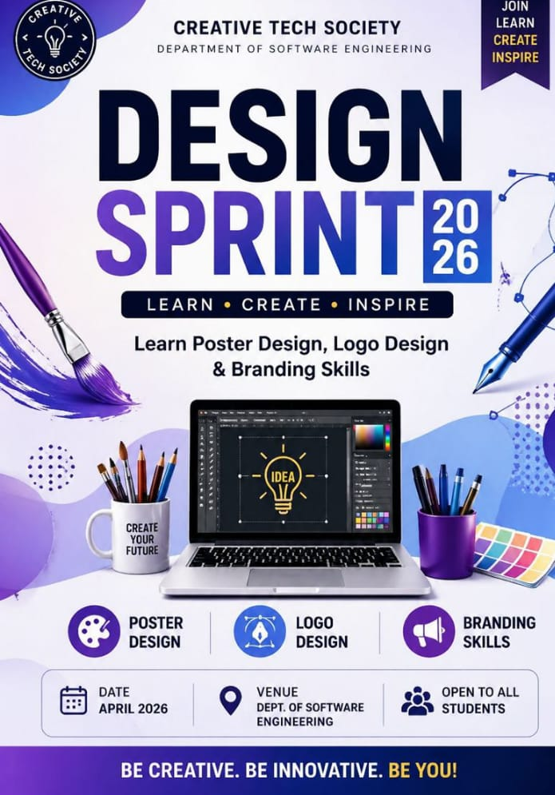

🟦 Promotional Poster – Design Sprint 2026
Concept & Purpose:
The purpose of this poster is to promote an event called Design Sprint 2026.
It is designed to attract students interested in creative and technical skills.
The poster communicates key information in a visually appealing and clear way.
1. Layout Planning
The poster follows a vertical (portrait) layout.
Information is arranged using visual hierarchy:
Top → Heading
Middle → Main content
Bottom → Details
2. Typography
The main heading “Design Sprint 2026” is placed at the top center in a bold font.
Subheading “Organized by Creative Tech Society” is placed below it.
The main content is written in the center in readable font.
Font sizes are adjusted to create hierarchy and emphasis.
3. Color Scheme
A blue and purple gradient is used to represent creativity and technology.
White/light colors are used for text to maintain contrast and readability.
4. Use of Icons
Icons are used to visually represent the content:
🎨 Paintbrush icon → Poster Design
💻 Laptop icon → Logo Design
✨ Sparkle/Bulb icon → Branding Skills
Icons are placed on the left side of each text line for clarity.
5. Content Placement
Center:
“Learn Poster Design, Logo Design & Branding Skills”
Bottom:
Date (left side): April 2026
Venue (right side): Dept. of Software Engineering
6. Design Principles Applied
Balance: Equal spacing between elements
Contrast: Light text on dark background
Alignment: Center alignment for main content
Hierarchy: Important text is larger and more visible
Conclusion
The poster is clean, balanced, and easy to understand.
It effectively communicates the event details using visuals and text.

QNo:02
Logo Design – Creative Tech Society

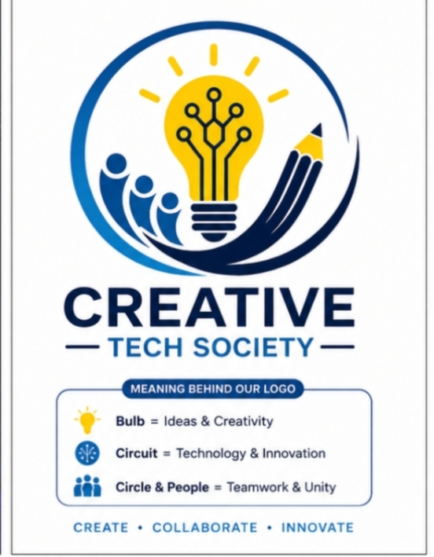

Logo Design – Creative Tech Society
Concept & Purpose
The logo represents the identity of Creative Tech Society.
It combines creativity and technology in a simple visual form.
Design Process (Step-by-Step)
1. Idea Development
The concept is based on:
Creativity (ideas, innovation)
Technology (digital tools, systems)
2. Shape Selection
A simple and clean shape (circle or abstract form) is used.
The shape keeps the logo modern and professional.
3. Elements Used
💡 Light bulb → Represents ideas and creativity
🔌 Circuit lines → Represents technology
These elements are combined into a single symbol.
4. Typography
The name “Creative Tech Society” is added below or beside the logo.
A clean and modern font is used.
5. Color Selection
Blue → Technology
Yellow → Creativity
Colors are kept minimal for simplicity.
6. Design Principles Applied
Simplicity: Easy to recognize
Scalability: Can be used in small or large sizes
Relevance: Matches the theme of tech and creativity
Conclusion:
The logo is simple, meaningful, and professional.
It clearly represents the organization’s purpose.

Qno:03
Campaign Poster – Save Energy

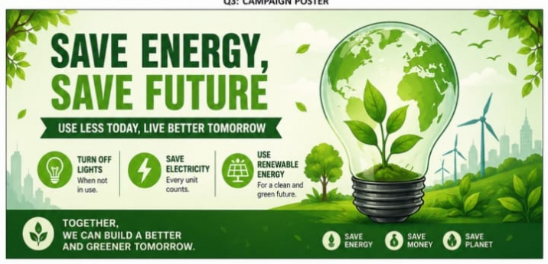

Campaign Poster – Save Energy
Concept & Purpose
The purpose of this poster is to spread awareness about energy conservation.
It encourages people to adopt eco-friendly habits.
Design Process (Step-by-Step)
1. Message Planning
Main message:
“Save Energy, Save Future”
Supporting lines:
“Switch off lights when not in use”
“Use renewable energy”
2. Visual Elements
A light bulb with Earth inside is used as the main visual.
Leaves and eco elements represent nature and sustainability.
3. Color Scheme
Green → Environment
Blue → Earth and sustainability
Soft colors are used for a calm and positive effect.
4. Layout Structure
Top:
Title (bold and clear)
Middle:
Main image (bulb + earth)
Bottom:
Awareness message
5. Design Principles Applied
Clarity: Message is short and easy to understand
Visual Communication: Image explains the idea
Balance: Proper spacing between elements
Contrast: Text is readable on background
Conclusion
The poster effectively delivers an environmental message.
It uses simple visuals and colors to create awareness.

